TECHNICAL REPORT
{Times New Roman 14 Point, Bold}

PRELIMINARY ENERGY AUDIT ON THE RESIDENTIAL HOUSE
TERRACE HOUSE
{Title: Times New Roman 24 Point, Bold}
{Subtitle: Times New Roman 20 Point, Bold, Italic}

Chang Ching Shen
Yap Ga Hung
Tan Hun Jian
Lee Chao Xiang
Kong Wei Seng
Tunku Nizar Tunku Mansor
Zainuddin Mat Isa
{Authors Name: Times New Roman 16 Point, Bold}

Penerbit Universiti Malaysia Perlis
Kangar 2020

{Times New Roman 12 Point}
~COPYRIGHT PAGE UniMAP Press)

©Universiti Malaysia Perlis, 2020

All rights reserved. No part of this book may be reproduced or transmitted in any forms by any means, electronic, mechanical, or otherwise, whether now or hereafter devised, including photocopying, recording, or by any information storage and retrieval system without express written prior permission from the publishers.

e-ISBN 978-967-0922-x-x

Published by:

Penerbit UniMAP, Universiti Malaysia Perlis
Tingkat 10, Bangunan KWSP
Jalan Bukit Lagi,
01000 Kangar, Perlis. MALAYSIA.

Tel: (04) 977 5159, Fax: (04) 977 5135
Website: http://penerbit.unimap.edu.my
E-mail: penerbitan@unimap.edu.my

TABLE OF CONTENTS
 | PAGE
LIST OF TABLES | iv
LIST OF FIGURES | v
ACKNOWLEGDEMENT | vii
PREFACE | viii
- INTRODUCTION  - Environmental Quality (Clean Air) Regulations 2014  - Objectives | 1  3
- PROJECT DEVELOPMENT PLAN | 4
- PROCESS FLOWSHEET AND PLANT LAYOUT  - Generating design concept  - Advantages and Disadvantages of Filter Baghouse System  - Characteristics of Particulate Matter  - Cleaning Mechanisms | 7  7  8  8
- DETAIL DESIGN WORK  - Design Procedure  - AutoCAD Drawing | 10  13
- SAFETY, HEALTH AND ENVIRONMENTAL CONSIDERATION  - Hazard Identification, Risk Assessment and Risk Control  - Hazard and Operability (HAZOP) Worksheet | 17  17
- ECONOMIC EVALUATION  - The Equipment Cost  - Bare Baghouse Costs  - Total Annual Costs Estimation  - Direct Annual Cost  6.2.1.1 Operating and Supervisory Cost  6.2.1.2 Operating Materials  6.2.1.3 Maintenance  6.2.1.4 Replacement Parts  6.2.1.5 Utilities  - Indirect Annual Cost | 23  26  26  26  27  27  29
- CONCLUSION | 31
- REFERENCES | 32
- APPENDIX | 34
LIST OF TABLES
Table 1.1 | Fuel quality parameter for fuel burning equipment | 2
Table 1.2 | Pollutants limiting values for combustion emission for solid and liquid fuels | 2
Table 1.3 | Limiting values for the pollutants of kiln | 6
Table 2.1 | Factors on Choosing Filter Media | 6
Table 3.1 | Advantages and disadvantages of filter baghouse system | 7
Table 3.2 | Cleaning parameters of mechanical shaker, reverse air and pulse jet mechanisms | 8
Table 3.3 | Advantages and Disadvantages of Cleaning mechanism | 9
Table 4.1 | The collection efficiency of different outlet flow rate | 12
Table 5.1 | The HIRARC form of the proposed project | 18
Table 5.2 | The HAZOP form for the proposed project | 21
Table 6.1 | List of cost curves for three baghouse types | 23

LIST OF FIGURES
Figure 2.1 | Project location | 4
Figure 2.2 | Project’s Located Point | 5
Figure 4.1 | Front view of filter baghouse system | 13
Figure 4.2 | Side view of filter baghouse system | 13
Figure 4.3 | Inlet flange and outlet flange of filter baghouse system | 14
Figure 4.4 | Access port and slide gate installed at hopper of filter baghouse system | 15
Figure 4.5 | Access port and strike plate installed at hopper of filter baghouse system | 15
Figure 4.6 | Simple diagram of system with a near-integrating process response of baghouse | 16
Figure 6.1 | Equipment Costs for Pulse-Jet Filters (Common-housing) | 24
Figure 6.2 | Equipment Costs for Pulse-Jet Filters (Modular) | 24
Figure 6.3 | Equipment Costs for Cartridge Filters | 25

ACKNOWLEDGEMENT
{Times New Roman 14 Point ~Heading 1[Bold]}

Firstly, we want to extend our thanks to Universiti Malaysia Perlis (UniMAP) and the School of Computer and Communication Engineering (SCCE) for giving us such an opportunity that allows us to practice the knowledge we had gained throughout the years of study by implementing it in a real-life situation of problem solving.
We would also like to show immense gratitude and say thank you to our supervisors, Ts. Dr. Ku Nurul Fazira Ku Azir and Ir. Ts. Dr. Junita Mohd Nordin for their kind and understanding spirit in guiding us and giving encouragement during the process of completing the project. Without their assistance and dedicated involvement in every step throughout the process, this paper would have never been accomplished.
We thank all the people for their help directly and indirectly to complete our project. We are grateful to all of those with whom we had the pleasure to work during this project. Sincere thanks to all group members for their cooperation and great teamwork from the starting point to the ending of our project. Everyone played an important role that led to the completion of the project.

{Times New Roman 12 Point ~Body Text, Roman, Single Spacing}

PREFACE
{Times New Roman 14 Point ~Heading 1[Bold]}

Inventory Management System is important to ensure everything is in order when handling huge amounts of materials and its quality within huge facilities such a factory’s warehouse. It is important to keep track of fluctuation of incoming and outgoing materials that happen daily for these facilities. It is also a useful tool to monitor the shortage of materials which may affect the production rate of the factory. The problem at hand is that the current inventory management being used is time consuming and difficult.
One way to do such inventory management is by having a Windows Form application system with C# language that can instantly track and update the information on materials. The objective is to provide a better management system that is better and have more functionality compared to the previous system being used. To achieve this, the scope of this project is to focus on the aspects such as to make, delete inventory, add new inventory, keeping track of inventory materials, supplier and order. This information will be stored within the database. This also allows to alert when materials are running low.
In developing the system, Waterfall development method is chosen. Firstly, a mind map is drawn to group and arrange each function. Before the next process will begin, each step must be fully fulfilled. This makes it easier to focus on the flow in achieving the project scope. The expected result of the system’s user interface will be user-friendly which will enable even people with no IT background to be able to handle it easily. The system is also expected to serve its functionalities and reduce the workload of the inventory management.

{Times New Roman 12 Point ~Body Text, Roman, Single Spacing}

INTRODUCTION {Times New Roman 14 Point ~Heading 1[Bold]}

The project proponent is Cement Industries of Malaysia Berhad (CIMA). All the necessary information pertaining to the project to the consultant to facilities for the upgrading the APC system designs are provided by them. The proponent concurred and acknowledges the content of this report including the design criteria.
Negeri Sembilan Cement Industries Sdn. Bhd. (NSCI), Perlis is one of the Portland cement producers in Malaysia, which involves processes such as selecting, grinding, heating, cooling and packaging. Each one of these processes discharges certain amount of particulate matter (PM) and harmful gases. However, when considering budget, only selected processes with higher particulate matter and harmful gases emission will be equipped with Air Pollution Control System (APC). The processes that take place in coal mill, kiln and grinder are the most likely to release high emission of particles, thus suitable air pollution control equipment is needed.
In this study, the problem related to the under-capacity performance of coal mill at Portland cement plant from Negeri Sembilan Cement Industries Sdn. Bhd. (NSCI) company in Perlis will be addressed. The inefficiency of filter bag house at coal mill is viewed as one of the reasons for this under performance. Filter bag house role is to collect and filtrate the coal during combustion at the coal mill. Previously in NSCI, the coal mill was able to produce up to 14 tonnes of pulverized coal in an hour but due to some unknown explanation, the amount of pulverized coal that enter the storage decreases to 12 tonnes per hour. So, any problem-related aspect of filter baghouse such as dimensions for the baghouse system, support designs and filter cloth will be discussed.
For the specification of filter cloth provided or manufactured by manufacturer, NSCI is currently using a woven type fabric filter made up of glass fibre. The strength of fabric filter came into focus since information regarding low magnehelic pressure of the filter bag house has been issued by one of the NSCI staff during the site visit. Magnehelic pressure is used in the industry to measure filter resistance, fan and blower pressure, velocity of air and pressure drop across the fabric. The drop in the magnehelic pressure indicated the presence of hole on the fabric. Hence, it is important to evaluate and compare the characteristics of different types of filter bag media to prevent problem from occurring in the future. The suitable dimension and modification on the support design and parameters such as cleaning mechanism and temperature will be analysed thoroughly. This is to reduce the problem such as choking and fabric tearing of the bag filter at the coal mill that will surely take a toll on the plant performance.

  - Environmental Quality (Clean Air) Regulations 2014
{Times New Roman 12 Point ~Heading 2[Bold]}

Environmental Quality (Clean Air) Regulations 2014 is the substitution to the Environmental Quality (Clean Air) Regulations 1978. Gazetted on 4th June 2014 and started enforced on the 5th June 2014. It is applicable for premises that conducts burning or incineration (of waste, materials etc) activity, premise that discharges air pollutants into the open air any fuel burning equipment any industrial plant. The regulation related to the emission in CIMA cement is Regulation 13 that stated:

“All activities and industries specified in the First Schedule shall comply with the technical standards and limiting values as specified in the Second and Third Schedules, as the case may be”.
Since NSCI is a mineral-based industry and uses mega fuel burning equipment, it can be categorized under activities listed in the First Schedule of Non-Metallic (mineral) Industry Cement Production (All-Sizes). Referring to the Second Schedule for liquid and solid fuel type. The control of fuel quality and combustion emission for fuel burning equipment in general is as listed below:

Table 1.1: Fuel quality parameter for fuel burning equipment

Fuel Type | Fuel | Fuel quality parameter
Liquid | All | Sulphur content <500 ppm (per weight)
Solid | Coal | Sulphur content <1% (per weight)
 | Biomass | Wood, agricultural waste, etc.: air dry and in its natural composition (e.g., wood without coating, paint or other treatment)
 |  | Residues from wood-based industries: without wood preservatives

Table 1.2: Pollutants limiting values for combustion emission for solid and liquid fuels

Fuel type | Pollutant | Limit value | Monitoring
Liquid | Total particulate matter (PM)  Where dust load emitted:  - >0.33<1.0 kg/hr  - $≥$1.0 kg/h | 50 mg/m³ | Once/year  2 times/year
Solid | Total particulate matter (PM)  Where dust load emitted:  - >0.44<1.0 kg/hr  - $≥$1.0<1.5 kg/h  - $≥$1.5<2.0 kg/h  - $≥$2.0 <2.5 kg/h  - $≥$2.5 kh/h | 150 mg/m³ | Once/year  2 times/year  3 times/year  4 times/year  Continuous*
 | Carbon monoxide (CO) | 1000 mg/m³ | Periodic
*Averaging time for continuous monitoring is 30 minutes

Third schedule address the limiting values and technical standard according to the activities in the industries. The proposal for this project will need to comply with the limiting values listed in the Non-Metallic (Mineral) Industry: Cement Production (All Sizes)

Table 1.3: Limiting values for the pollutants of kiln
Source | Pollutant | Limit value | Monitoring
Cement kilns | Sum of NO and NO₂ expressed as NO₂ | 800 mg/m³ | Continuous*
 | Total PM | 50 mg/m³ | Continuous*
 | Mercury | 0.05 mg/m³ | Periodic
 | PCDD/PCDF | 1.0 ng TEQ/m³ | Periodic

PROJECT DEVELOPMENT PLAN

One of the top cement suppliers in Malaysia is Cement Industries of Malaysia Berhad (CIMA), which is a subsidiary company of the UEM Company Berhad. It has been well known for manufacturing and supplying high quality cement, ready-mixed concrete and related products from 1975. CIMA's corporate office is situated in Petaling Jaya, Selangor, and has two strategic locations in Bukit Ketri, Perlis and Bahau, Negeri Sembilan, which are known as the Negeri Sembilan Cement Industries Sdn Bhd. Both plants have a gross production capacity of 7.2 million tons of cement per year.
Both plants are supplying an Ordinary Portland Cement/CEM1 (OPC), ASTM Type II Portland Cement, Low Heat Cement, Masonry Cement and Portland Composite Cement (PCC). Commonly consumed materials for cement production are sand (silica), iron oxide, alumina and limestone. These materials contain different properties and each of them each plays a vital role in creating variety of cement. The study was conducted at Negeri Sembilan Cement Industries Sdn Bhd. Perlis plant (Figure 2.1). It is located with latitude 6.511816 and longitude of 100.257870 with a total area almost 4,000,000 ft² were completely equipped with technology and machines on cement production.

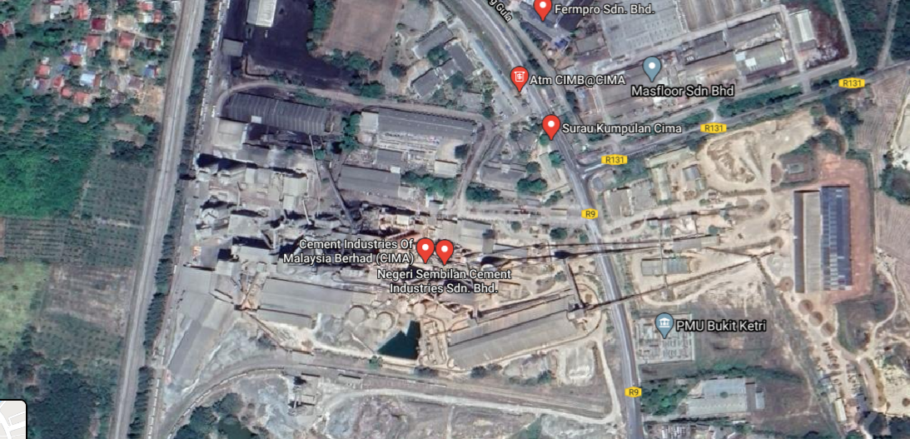
Figure 2.1: Project Area
Cement production needs four type of materials which are sand, iron oxide, alumina and actually a huge portion of limestone. Most of these raw materials are acquired from the limestone quarry excavation. Limestone quarry is chosen due to the high content of limestone contain in it. Thus, by excavating limestone other than limestone itself, we already have all the raw materials necessary for cement production.

Based on Figure 2.2, our study area is located at stage 2 where the filter baghouse was located. At coal mill, the coal supply will be grinding, dried, classified and transported the product to the kiln by undergo the process of filter first. The finer particle of the product will be penetrated or trap to filter baghouse and due to gravity, the particle will drop as solid to the coal storage while the clean air emits to atmosphere. The under capacity happened at this area where baghouse cannot fully trap the coal supplied.

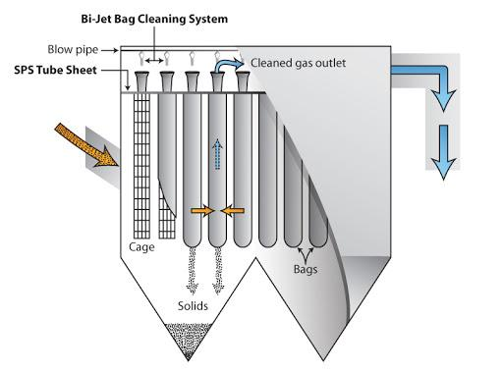

Figure 2.2: Project’s Located Point

Nevertheless, the physical process in cement manufacture has a lot of issues especially when it comes to environmental. In general, cement plant contributes to emissions of water, noise quality and air emissions which is the most prominent one. The main pollutants in Portland cement production are particulate matter (PM and PM₁₀), nitrogen oxides (NO_{x}), SO₂, carbon monoxide (CO) and CO₂. As of the industries needs to follow the regulation to continue their business activity. A lot of control measure have been established to guarantee that the cement plant complies with the standard regulation of Clean Air Act 2014.
The main aim of the project is to evaluate the performance of filter baghouse to further lower the particulates outlet loading to values less than the stipulated standard (control air pollution). Appropriate bag house filter media has to be chosen to maximize efficiency, raise filter life, reduce system maintenance, and thus save money. With so many various types of bag house filter fabrics and treatment methods to choose between, we may detect which one is better suited to the application of CIMA. Table 2.1 indicates the four key considerations that will be weighed before the filter media is selected: to evaluate the performance of filter baghouse to further lower the particulates outlet loading to values less than the stipulated standard (control air pollution)
Second objective is to provide dimensions for the baghouse system based on the key performance evaluated. The performance factors that are considered are the effects of particle charge, the air-to-cloth ratio, and the inlet particulates loading. The third objective is to provide modifications on various supported designs in the baghouse to accommodate the new designed system. Taking into consideration a variety of variables for the re-designed baghouses to withstand the pressure drop, filter drag, air-to-cloth ratio, and collection capacity.

  - Pressure drop (∆p), a quite sensitive in the baghouse design feature, defines the resistance to air flow into the baghouse to achieve an optimal performance.
  - Reasonable air-to-cloth ratios are required to prevent high-speed effect of dust particles on the fabric, as this results in earlier time of bag replacement. To evaluate the acceptable filter size, we must analyze air-to-cloth ratio to fabric and the can velocity of the filter.

  - To maximize the can velocity of the bag filter compartment, the distance between the bags in each row as well as between the rows will be measured and specified for each particular event. This kind of criteria are often used to decide the most acceptable length of the bag and the number of compartments required.

Table 2.1: Factors on Choosing Filter Media

Factors | Explanation
Temperature | Because different media have varied optimum temperature ranges, the working temperature differences will be investigated to avoid filter media from exceeding the filter media’s bearable range.
Moisture Content | Air humidity is proportional to the point of dew. It is easy to create condensation in a filter bag with a high moisture composition and a high dew point that will influence the de-dusting results. We shall consider this most suitable filter media to avoid the filter media from brittle and damage.
Chemical composition | The anti-acid, anti-alkali and anti-organic solvent filter media must be chosen when there is a presence of acid, alkali or organic solvent in the dusty gas.
Combustibility and explosives | Fire retardant and anti-static filter materials should be utilized, if the dusty gas consists highly explosive gas,

PROCESS FLOWSHEET AND PLANT LAYOUT

DETAIL DESIGN WORK

  - Design Procedure

To design the filter baghouse system, some of the mathematical equations and calculations need to be applied. Baghouses are designed by their size and depend on gas-to-cloth ratio and "can velocity". Other than that, the pressure drop is also an important parameter to consider the efficiency of the filter baghouse. The collection efficiency is the most important to determine the characteristics of the filter baghouse. The following are the procedure established for the calculation of baghouses design.

    - Gas-to-cloth ratio

The gas-to-cloth ratio is the measure of the amount of gas emitted by each square foot in the baghouse. It is given in terms of the number of cubic feet of gas per minute passing through one square foot of cloth. In other words, the G/C ratio is equal to the gas volume rate/cloth area. Also note that this velocity is not the actual velocity through the openings in the fabric, but rather the possible velocity of the gas surrounding the cloth. When the G/C ratio is increased, the pressure drop also will increase. The baghouses that usually have the highest gas-to-cloth ratio is pulse jet baghouses. A high gas-to-cloth ratio means that there is a large volume of dirty air passes through the bags at a given time.
Factors affecting the G/C include the cleaning process, filter media, dust capacity, dust quantity, dust loading, and other factors that differ from each situation. Once the gas/cloth ratio (G/C) has been decided, the size of the baghouse is nearly installed. Variations also occur in the number of walkways, hopper slope, and other design problems. These different modifications will influence the total capacity of the baghouse to a limited degree, once G/C has identified the essential requirements.

$$\frac{Units gas}{cloth ratio}= \frac{gas volume rate}{total cloth area}= \frac{{ft}^{3}/min}{{ft}^{2}}=ft/min$$

For the pulse jet filter baghouse with felted fabric for coal:
G/ C = 3.5 ft/min
= 0.01778 m/s

2. Gas flow rate
Area of filter baghouse

$$A=πDL$$
Where, A=bag surface area, m²
D=bag diameter, m
L=bag length, m

SAFETY, HEALTH AND ENVIRONMENTAL CONSIDERATION

Hazard Identification, Risk Assessment and Risk Control

Bag failures occur at varying times depending on the operation of the collector. Hence, it is important to schedule monitoring and maintenance activities of the bag houses. The bag house that is maintained properly will ensure the smooth run for filtration process as the possibilities for damaged can be avoided. The hazard identification, risk assessment and risk control is identified as in the following Table 5.1.

Hazard and Operability (HAZOP) Worksheet

Hazard and Operability (HAZOP) report is a comprehensive approach to recognize hidden dangers in the working system. In this method, the procedure is broken down into stages, and any change in the function parameters is evaluated from each step to see what might go wrong. The report extensively examines the growing aspect of the system. The purpose is to detect possible scenarios that might allow the item to present a danger or to restrict the activity of the system as a whole. The HAZOP report is carried out during the planning stage of the new project. The success of the analysis ensures that all possible sources of failure will be known. The HAZOP report would include an overview of the possible deviations, consequences, causes, safeguard and recommendation. From this stage on, improvements to the program will be made to eliminate issues from happening. In the ongoing facilities, HAZOP has been operating to enhance the procedure without any defined end date. The HAZOP worksheet for this research was developed using Process Hazard Analysis (PHAWorks) software and tabulates in Table 5.2.

ECONOMIC EVALUATION

Total capital investment includes the baghouse structure costs, bags’ initial complement costs, auxiliary equipment costs, usual direct costs and indirect costs correlated with installing or erecting new structures. These costs are introduced below.

The Equipment Cost

Bare Baghouse Costs
{Times New Roman 14 Point ~Heading 3[Bold,Italic]}

Relationship between cost and fabric area for 3 types of baghouses are presented. These three types which are preassembled are listed in Table 6.1. Figures 6.1 and 6.2 show common-housing and modular pulse-jet baghouses, respectively. Common housing units have all bags within one housing; modular units are constructed of separate modules that may be arranged for off-line cleaning. Note that in the single-unit (common-housing) pulse jet, for the range shown, the height and width of the unit are constant and the length increases; thus, for a different reason than that for the modular units discussed above, the cost increases linearly with size. Because the common housing is relatively inexpensive, the stainless-steel add-on is proportionately higher than for modular units. Added material costs and setup and labor charges associated with the less workable stainless-steel account for most of the added expense. Figure 6.3 shows costs for cartridge baghouses cleaned by pulse.

Table 6.1: List of cost curves for three baghouse types
 | Baghouse Type | Figure No.
 | Preassembled Units
Continuous | Pulse-jet (common housing) | 6.1
Continuous | Pulse-jet (modular) | 6.2
Continuous | Pulse-jet (cartridge) | 6.3

Figure 6.1: Equipment Costs for Pulse-Jet Filters (Common-housing)

Figure 6.2: Equipment Costs for Pulse-Jet Filters (Modular)

The capital cost factors are calculated as the following:

Cost Item | Factor (MYR)
Direct costs
Purchased equipment costs
Fabric filter (EC) | 60,000
Bags | 28,000
Auxiliary equipment | 12,000
Total, A | 100,000
Instrumentation, 0.10A | 10,000
Sales taxes, 0.03A | 3,000
Freight, 0.05A | 5,000
Purchased Equipment Cost, PEC, B = 1.18 A | 118,000
Direct installation costs
Foundations & supports, 0.04 B | 4,720
Handling & erection, 0.50 B | 59,000
Electrical 0.08 B | 9,440
Piping, 0.01 B | 1,180
Insulation for ductwork, 0.07 B | 8,260
Painting, 0.04 B | 2,360
Direct installation costs, 0.74 B | 84,960
Total Direct Cost, DC, B+ 0.74B = 1.74 B | 202,960
Indirect Costs (installation)
Engineering, 0.10 B | 11,800
Construction and field expense, 0.20 B | 26,600
Contractor fees, 0.10 B | 11,800
B Start-up, 0.01 B | 1,180
Performance test, 0.01 B | 1,180
Contingencies, 0.03 B | 3,540
Total Indirect Cost, IC, 0.45 B | 53,100
Total Capital Investment = 1.74 B + 0.45 B = 2.19 B | 256,060

The construction estimation cost of the baghouse filter including equipment costs, installation cost and total capital investments estimated around RM 256,060. The equipment cost including fabric filter with insulation, bag, cages and auxiliary equipment which is RM 118,000 while for total indirect cost is RM 202,960.

  - Total Annual Costs Estimation

    - Direct Annual Costs

Direct annual costs include operating and supervisory labor, operating materials, replacement bags, maintenance, utilities, and dust disposal. Majority costs are talked separately below. They differ with place and time and should be gained to fit the particular baghouse system being costed.

      - Operating and Supervisory Cost

Typical operating labor requirements are 3 hours per 8-hours shift for a wide range of filter sizes. When fabric filters are operated to meet Maximum Achievable Control Technology (MACT) regulations, it is likely that the upper end of the range is suitable. Small or well-performing units may need less time, while very large or troublesome units may need more. Supervisory labor is taken as 15% of operating labor.

Operator cost (OL): requirement of 3 h per 8 h shift = RM56.21/h
Annual cost of OL = (3 h/shift / 8 h/shift) X 6,000 hours/year X RM56.21/h = RM12,472.50
Supervisory cost (SL): 15 % of OL = 0.15 x RM 12,472.50 = RM 1,870.88

      - Operating Materials

Operating materials are usually not essential for baghouses. An exception is the precoat materials used injected on the inlet side of the baghouse to give a layer with protective dust on the bags when adhesive or destructive particles may hurt them. Adsorbents might be injected in the same way while the baghouse is used for simultaneous particle and removal of gas. Materials costs shall be cover on a dollars-per-mass.

CONCLUSION

First, the online MySQL server does not support stored procedure. The reason we preferred using stored procedure over writing the query along with C# coding is because it is easier to maintain the system. Sometimes a particular query function will be used by more than one function in C# therefore instead of editing each same part separately we can access it all at once with stored procedure. As the inventory system control all the inventory, which is an asset for the company, the security of the system should be emphasis in the future. The security vulnerable such as SQL injection can be critical. Unlike web application which hacker can perform injection through user input, hacker should have obtained the desktop application since the application can directly connect to database. Hence, stored procedure is also considering as an intermediate layer to prevent hacker directly access to the database tables.
Other than stored procedure, since the online database is free, we may expect some time delay when fetching the data which may cause connection timeout when applications are attempted to connect with it. Performance of application are slowed down due to the slow database connection speeds which limits the use of online database in desktop application. In near future, a better and faster paid online database should be considered or maybe switch to more powerful cloud computing service such as Microsoft Azure.
There are more limitations in desktop application. Since desktop application is using .NET framework instead of .NET core, it is unable to run on operating system other than Windows. Although .NET core allows cross-platform on application, as we are not computer science student and most of us are not very fluent in programming, .NET framework is much easier to learn and implement. In future, we can migrate system from .NET framework to .NET core for more scalable application.
Besides from the limitations that we mentioned above, there are more improvement that can be done in future. Some solutions like cloud storage might be costly but the features they provided is totally worth it and we can see it as an investment. The system with good cloud server would be able to speed up activities in inventory activities and perhaps it is more than just inventory but the entire activities in industry.

Summary
Thus, a comprehensive inventory management system was developed that might help NAM manage their stocks, car model information, and also car manufacturing process using the barcode inventory system. It would minimize the worker's efforts to maintain the track of each object manually, and their hassle of maintaining the log as it will be stored in the database.
The project also has the potential to notify the company if any products fall below the level of the recorder and the products in-store as well as the amount available in the store. The project has an efficient security system by using stored procedure in MySQL, among other achievements, which makes the documents highly confidential using an effective password program.
Good inventory system often because of the system has proper maintenance from programmer from time to time. Although the system has a lot of improvement now, but it should be always maintained by programmer and update the best possible features for company to deal with changing technical and management environment. There is no perfect inventory but best inventory that fits the environment of the company and therefore lead to more organized warehouse with minimum cost

REFERENCES

Bao, L., Yu, M., Kishma, T., Uyama, S., & Kemmocchi, K. (2011). Improving bag cleaning efficiency of a bag filter dust collector using multiple jet pulses. T Jpn Soc Mech Eng, Series C, 77, 179-186.
Carr, R. C., & Smith, W. B. (1984). Fabric filter technology for utility coal-fired power plants. Journal of the Air Pollution Control Association, 34(1), 79-89.
Litchwark, J. O., Winchester, J., & Nijdam, J. J. (2015). Design of pulse-jet systems for milk powder baghouses. Powder Technology, 284, 379–386.
Lu, H. C., & Tsai, C. J. (1998). A Pilot-Scale Study of the Design and Operation Parameters of a Pulse-Jet Baghouse. Aerosol Science and Technology, 29(6), 510–524.
Lu, H. C., & Tsai, C. J. (1999). Influence of design and operation parameters on bag cleaning performance of pulse-jet baghouse. Journal of Environmental Engineering, 125(6), 583–591.
Lu, H. C., & Tsai, C. J. (2003). Influence of different cleaning conditions on cleaning performance of pilot-scale pulse-jet baghouse. Journal of Environmental Engineering, 129(9), 811–818.
Mohurle, N., & Thakare, N. R. (2013). Analysis on fabric filtration material for pulse jet fabric filter. Int. J. Emg. Tech. Adv. Eng, 3, 603.
Mukhopadhyay, A. (2009). Pulse-jet filtration: An effective way to control industrial pollution
Part I: Theory, selection and design of pulse-jet filter. Textile Progress, 41(4), 195-315.
Pham, M., Clark, C., & McKenna, J. (2012). The evolution and impact of testing baghouse filter performance. Journal of the Air and Waste Management Association, 62(8), 916–923.
Scala, F., Lancia, A., Nigro, R., & Volpicelli, G. (2005). Spray-dry desulfurization of flue gas from heavy oil combustion. Journal of the Air and Waste Management Association, 55(1), 20–29.
Simon, X., Bémer, D., Chazelet, S., & Thomas, D. (2014). Downstream particle puffs emitted during pulse-jet cleaning of a baghouse wood dust collector: Influence of operating conditions and filter surface treatment. Powder Technology, 261, 61–70.
Simon, X., Bémer, D., Chazelet, S., Thomas, D., & Régnier, R. (2010). Consequences of high transitory airflows generated by segmented pulse-jet cleaning of dust collector filter bags. Powder Technology, 201(1), 37–48.
Turner, J. H., Viner, A. S., Jenkins, R. E., Vatavuk, W. M., & McKenna, J. D. (1987). Sizing and costing of fabric filters part II: Costing considerations. JAPCA, 37(9), 1105-1112.

APPENDIX

Antenna Gantt Chart Development (EXAMPLE)

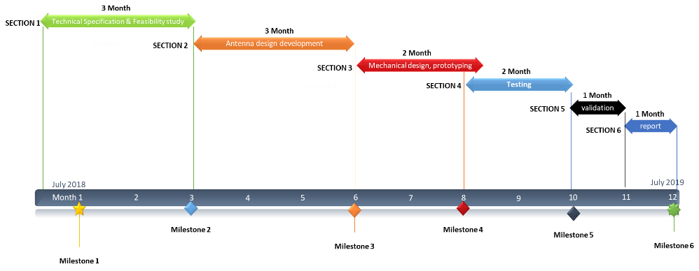

Milestone 1
Milestone 2
Milestone 3
Milestone 4
Milestone 5
Milestone 6

TECHNICAL DRAWING (MECHANICAL DESIGN) – {EXAMPLE}

Universiti Malaysia Perlis (UniMAP_ | Designed by xxx
Institution | Approved | Date | Rev
Scale 1 : 2 | Material: xxx
Product Name: xxx

